 | 24 Editors - Toolbar
Table of content
Detailed Table of Content 1
Introduction 9
Limits 9
Menus 10
Toolbar Manager 10
Toolbars Menus 10
Bforartists Settings add-on 10
Create new toolbar 11
Save Toolbar state 11
Toolbar Manager 12
Toolbar Types 12
Options 12
Toolbars File 13
Available Toolbars 13
Toolbars Mesh Edit 18
Available Toolbars 18
Toolbars Primitives 22
Available Toolbars 23
Toolbars Image 29
Available Toolbars 30
Toolbars Tools 32
Available Toolbars 32
Toolbars Animation 35
Available Toolbars 35
Toolbars Edit 38
Available Toolbars 38
Toolbars Misc 42
Available Toolbars 42
Viewport 42

Detailed Table of Content

23 Editors - Toolbar
Detailed Table of Content 1
Introduction 9
Limits 9
Menus 10
Toolbar Manager 10
Toolbars Menus 10
Bforartists Settings add-on 10
Create new toolbar 11
Save Toolbar state 11
Toolbar Manager 12
Toolbar Types 12
Options 12
Show Quick Toggle 13
Toolbars File 13
Available Toolbars 13
Load / Save 13
File New 13
New from Template 13
Open 14
Open Recent 14
Save Blend File 14
Save As Blend File 14
Save Copy 14
Recover 14
Revert 14
Recover Last Session 14
Recover Autosave 14
Link Append 14
Link from Library 14
Append from Library 14
Import Menu 15
Export Menu 15
Import Common 15
Import FBX 15
Import FBX 15
Import Obj 15
Import ABC 15
Import Common 2 15
Import BVH 15
Import USD 16
Import glTF2 16
Import Uncommon 16
Import PLY 16
Import SVG 16
Export Common 16
Export FBX 16
Export Obj 16
Export ABC 16
Export Common 2 16
Export BVH 16
Export USD 16
Export gITF2 16
Export Uncommon 17
Export PLY 17
Render 17
Render Image 17
Render Animation 17
Viewport Render 17
Viewport Render Image 17
Viewport Render Animation 17
Render Misc 17
Mixdown Audio 17
Show/ Hide Render view 17
Play rendered animation 17
Toolbars Mesh Edit 18
Available Toolbars 18
Vertices Split connect 18
Split 18
Vertex Connect Path 18
Vertex Connect 18
Vertices Misc 18
Convex Hull 18
Blend from Shape 18
Shape Propagate 19
Edges Subdiv 19
Subdivide 19
Subdivide Edge Ring 19
Un-Subdivide 19
Edges Sharp 19
Mark Sharp 19
Unmark Sharp 19
Set Sharpness by Angle 19
Edges Freestyle 19
Mark Freestyle Edge 19
Unmark Freestyle Edge 19
Edges Rotate 19
Rotate 19
Edges Misc 20
Edge Split 20
Bridge Edge loops 20
Faces general 20
Fill 20
Grid Fill 20
Beautify Faces 20
Solidify 20
Intersect 20
Boolean Intersect 20
Wire Frame 20
Faces Freestyle 20
Mark Freestyle Face 20
Unmark Freestyle Face 20
Faces Tris 21
Poke Faces 21
Triangulate Faces 21
Tris to Quads 21
Split by Edges 21
Faces Rotate Misc 21
Rotate UV's 21
Reverse UV's 21
Rotate Colors 21
Reverse Colors 21
Cleanup 21
Delete Loose 21
Decimate Geometry 21
Degenerate Dissolve 21
Make Planar Faces 21
Split Non Planar Faces 22
Split Concave Faces 22
Fill Holes 22
Toolbars Primitives 22
Available Toolbars 22
Mesh 22
Add Plane 22
Add Cube 22
Add Circle 22
Add UV Sphere 23
Add Cylinder 23
Add Cone 23
Add Torus 23
Add Grid 23
Curve 23
Add Bezier 23
Add Circle 23
Add Nurbs Curve 23
Add Nurbs Circle 23
Add Nurbs Path 23
Surface 23
Add Surface Curve 23
Add Surface Circle 24
Add Surface Patch 24
Add Surface Cylinder 24
Add Surface Sphere 24
Add Surface Torus 24
Metaball 24
Add Metaball of type Ball 24
Add Metaball of type Capsule 24
Add Metaball of type Plane 24
Add Metaball of type Ellipsoid 24
Add Metaball of type Cube 24
Point Cloud 24
Add Point Cloud 24
Volume 25
Import OpenVDB Volume 25
Add Volume 25
Grease Pencil 25
Blank 25
Stroke 25
Monkey 25
Scene Line Art 25
Collection Line Art 25
Lamp 25
Add Lamp of type Point 25
Add Lamp of type Sun 25
Add Lamp of type Spot 26
Add Lamp of type Area 26
Other 26
Add Text 26
Add Armature 26
Add Lattice Deformer 26
Add Lattice 26
Add Camera 26
Add Speaker 26
Empties 26
Add Empty of type Plain Axes 26
Add Empty of type Sphere 26
Add Empty of type Circle 26
Add Empty of type Cone 27
Add Empty of type Cube 27
Add Empty of type Single Arrow 27
Add Empty of type Arrows 27
Add Empty of type Image 27
Image 27
Images as Planes 27
Light Probe 27
Sphere 27
Plane 27
Volume 27
Force Field 27
Add Physics Effector of Type Boid 27
Add Physics Effector of Type Charge 28
Add Physics Effector of Type Curve Guide 28
Add Physics Effector of Type Drag 28
Add Physics Effector of Type Force 28
Add Physics Effector of Type Harmonic 28
Add Physics Effector of Type Lenard-Jones 28
Add Physics Effector of Type Magnetic 28
Add Physics Effector of Type Fluid Flow 28
Add Physics Effector of Type Texture 28
Add Physics Effector of Type Turbulence 28
Add Physics Effector of Type Vortex 28
Add Physics Effector of Type Wind 28
Collection 28
Add Collection Instance 28
Toolbars Image 29
Available Toolbars 29
UV Mirror 29
UV Rotate 29
UV Align 29
Align Straighten 29
Align Straighten X 29
Align Straighten Y 29
Align Auto 29
Align X 29
Align Y 29
Align Rotation 30
UV Unwrap 30
Mark Seam 30
Clear Seam 30
Seams from Islands 30
Unwrap Angle Based 30
Unwrap Conformal 30
Unwrap Minimize Stretch 30
Cube Projection 30
Cylinder Projection 30
Sphere Projection 30
UV Modify UV 30
Pin 30
Unpin 31
Weld 31
Remove Doubles UV 31
Average Island Scale 31
Pack Island 31
Copy mirrored UV Coordinates 31
Toolbars Tools 31
Available Toolbars 31
Parent 31
Make Parent 31
Clear Parent 31
Object to Data 32
Make Single User 32
Link Data 32
Link to SCN 32
Link to SCN 32
Linked Objects 32
Make Local 32
Make Library Override 32
Join 32
Join 32
Origin 33
Set Geometry to Origin 33
Set Origin to Geometry 33
Set Origin to 3D cursor 33
Set Origin to Center of Mass 33
Set Origin to Center of Volume 33
Shading 33
Shade Smooth 33
Shade Smooth by Angle 33
Shade Flat 33
Data Transfer 33
Transfer Mesh Data 33
Transfer Mesh Data Layout 33
Join UV's 34
Relations 34
Make Vertex Parent 34
Toolbars Animation 34
Available Toolbars 34
Keyframes 34
Insert Keyframe Menu 34
Delete Keyframe 35
Bake Action 35
Remove Animation 35
Calculate Object Paths 35
Clear Object Paths 35
Play 35
Jump to Endpoint 35
Jump to Keyframe 35
Play Animation 35
Play Animation 35
Jump to Keyframe 35
Jump to Endpoint 35
Current Frame 35
Range 36
Use Preview Range 36
Lock Frame Selection to Range 36
Frame Start 36
Frame End 36
Keying set 36
Insert Keyframe 36
Delete Keying set Keyframe 36
Use Keyframe Insert Auto 36
Keying set Drop down box 36
Sync 36
Keyframe Type 37
Toolbars Edit 37
Available Toolbars 37
Edit 37
Dissolve Vertices 37
Dissolve Edges 37
Dissolve Faces 37
Remove Doubles 37
Limited Dissolve 37
Dissolve Selection 38
Edge Collapse 38
Merge 38
Separate 38
Weight in Edit 38
Normalize all 38
Normalize 38
Mirror 38
Invert 38
Clean 38
Quantize 38
Levels 38
Smooth 39
Limit Total 39
Object Apply 39
Apply Location 39
Apply Rotation 39
Apply Scale 39
Apply All 39
Apply Rotation & Scale 39
Apply Visual Transform 39
Make Instances real 39
Apply Parent Inverse 39
Visual Geometry to Objects 39
Object Apply Deltas 39
Location 40
Rotation 40
Scale 40
All 40
Transforms to Delta Anims 40
Object Clear 40
Location 40
Rotation 40
Scale 40
Origin 40
Toolbars Misc 41
Available Toolbars 41
Viewport 41
Undo / Redo 41
Undo 41
Redo 41
Undo History 42
Undo History 42
Repeat 42
Repeat 42
Repeat History 42
Scene 42
View Layer 42
Adjust last Operation 42
Operatorsearch 43
Search Menu 43
Search Operator 43
Info 43

Introduction

The Toolbar editor is what you normally have to avoid in UI design. It's a bunch of double menu entries. It is made by lots of tools that already exists elsewhere.
But the value of this double menu here is that it is configurable. This customizable toolbar makes it possible to have the most needed tools at top UI level. This can save a ton of clicks, tabbing, scrolling, and digging in sub menus. And you can display what you need for your personal workflow. And hide away the rest.
The toolbar editor uses pure Icon buttons.
Parts of the toolbars are just visible when you are in the right mode. The full Primitives toolbar for example in just visible in Object mode. Parts of it are visible in Edit mode, dependent of what type of object you modify. And in the other modes the toolbars are hidden.
Parts of the toolbars are just visible when the right object type in the scene exists / is selected.
As told, the toolbars are double menu entries. This means the description of the tools in this chapter will be as short as possible. Closer descriptions, like how to use the tools, can be found in the other chapters where the tools comes from. The Tool Shelf in the 3D View for example.

Limits
- The toolbar does not contain all possible tools. More the opposite, the selection is very limited. Lots of tools depends to be performed in the editor type where you want to do the change. They just work there. And not in other editors. This affects for example most tools in edit mode. And the toolbar is another editor. This limits the available tools in the toolbar dramatically.
- The toolbars have a fixed order. The content is not sortable. The sorting is defined by the order of the toolbar type. And inside the toolbar type by the order in the toolbars menu. You would need to have to edit the python file to change this order.
- Just the toolbar types are independent. The check boxes to display the toolbars themselves are global. Means when you set one toolbar type to Primitives, and activate all the primitives types there, then other toolbars with this toolbar type will have the same primitives types displayed.

Menus
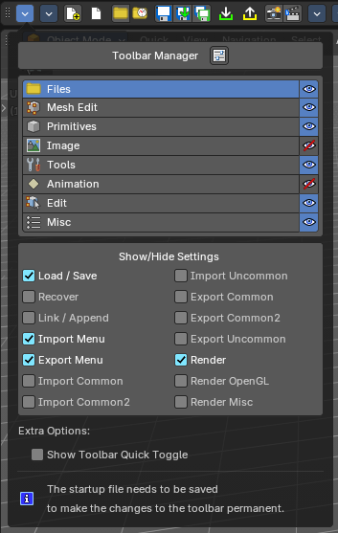

Toolbar Manager
The first entry of a toolbar is the Toolbar Manager.
Choose what kind of Toolbar Type you want to show. You can show multiple types of toolbars at once.
The toolbar types are independent from each other. You can set up every toolbar to display different content.

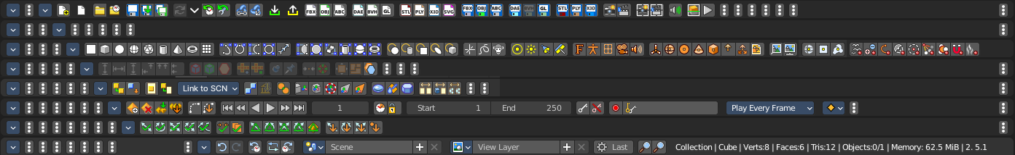

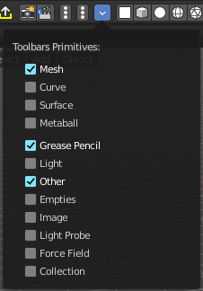
Toolbars Menus
Every toolbar type has several toolbars to display.
In the toolbar menu at the front of a toolbar type you can choose what toolbars you want to display.
The toolbars are not independent. This setup is global. When you for example tick the Toolbar File in this toolbar, then it will be displayed in all other toolbars too. Including in other layouts.
These check boxes are also available in the Toolbar Settings Bforartists add-on

Bforartists Settings add-on
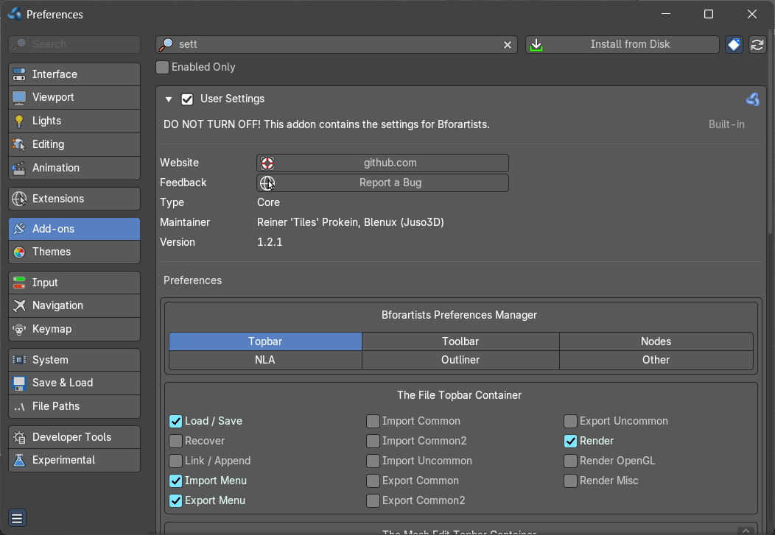
The settings for the toolbar needs to be stored somewhere. This is done in an add-on called Bforartists Settings.
This add-on contains the same check boxes than the single toolbars menus in the toolbar. But all of them at once.
Changing a setting here will automatically save the user preferences.

Warning!
Do not deactivate this add-on. The toolbar will not work then. It depends of the settings in the add-on!

Create new toolbar
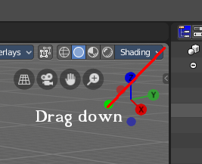
You might want to create your own toolbar for a new layout. Let's explain the needed steps.
First create a new editor type. This can be done by dragging the triangle area of an existing editor. And will create a new editor.
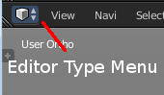
Look at the right of this new created editor type. You will now see a small button. This is the Editor type menu. Open it by clicking at it. And choose Toolbar.
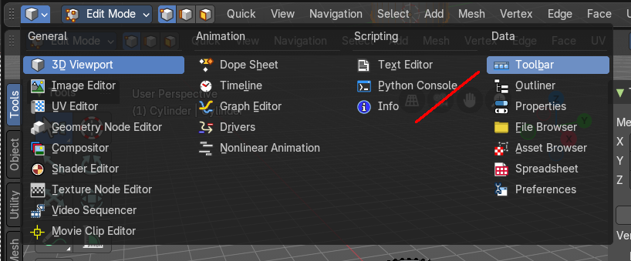

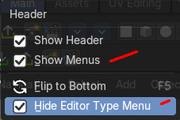
Now set up your new created Toolbar editor. Choose the toolbar types you want to display here. Then choose the toolbars to display.
The last step is to hide the Editor Type menu and to untick Show menus. Right click at the toolbar, and tick Collapse Menus and Hide Editortype menu.

Save Toolbar state

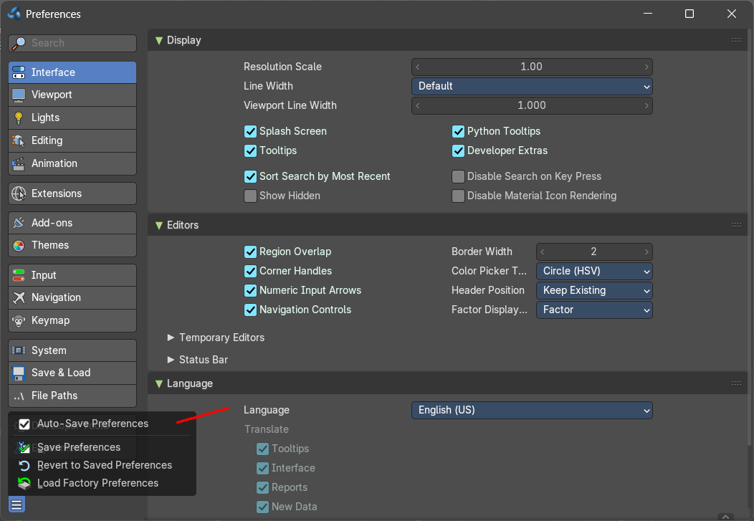
Because of the autosave Preferences feature changes in the menus of the single toolbars are stored automatically.
When you activate for example the Curve toolbar in the Primitives, then the curve toolbar will stay activated when you close and open Bforartists.

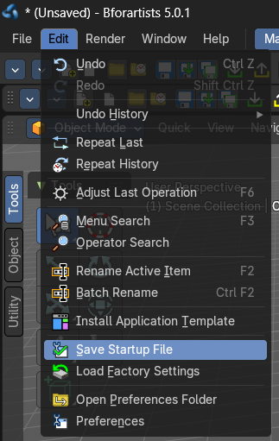
But the general setup of the toolbar type is layout. And so you have to save the startup file to make this changes permanent.

Be careful here. Saving the startup file saves every change at the layout. Including things like having a mesh in the scene.

Toolbar Manager

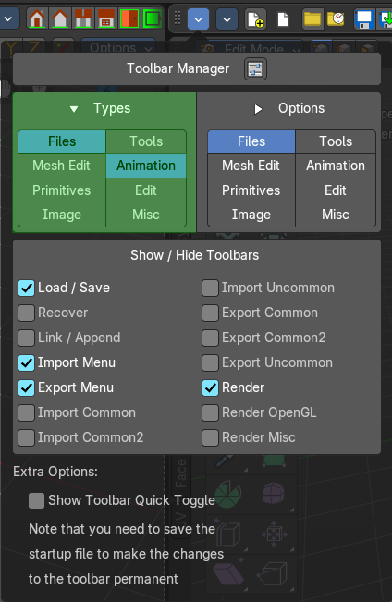
Currently the Toolbar editor contains eight toolbar types.

Toolbar Types
The single toolbar types.
Note that you need to save the startup file to make changes at the toolbar types permanent. They are part of the layout. Which was the only way to allow them to act independent from each other.
File - Contains some file menu related tools. Like load save. But also the render menu.
Mesh Edit - Contains tools for Meshes in Edit Mode.
Primitives - Contains the primitives from the Create tab in the Tool Shelf.
Image - Contains some tools for editing UV
Tools - Contains the content of the Relations panel in Object mode.
Animation - Contains Animation tools
Edit - Contains some tools from Object and Edit Mode
Misc - Contains Undo, and an empty menu as a place holder.

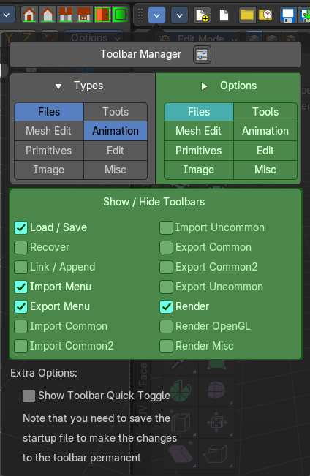
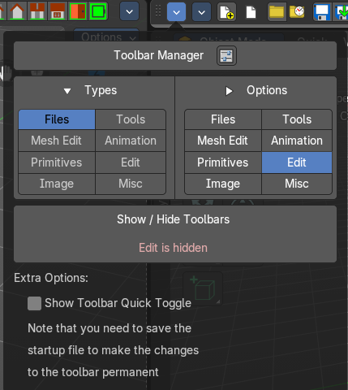
Options
Manage which part of the toolbar types is visible. This is the same content than the Toolbars menus.
Note that not active types will not show the toolbars menus content.

Show Quick Toggle
By default you need to turn on or off the toolbar types in the toolbar type menu. With quick toggles turned on you will reveal small buttons besides the single toolbar types that allows you to expand or collapse the toolbar types from within the toolbar. Each quick toggle represents a toolbar type.

Toolbars File

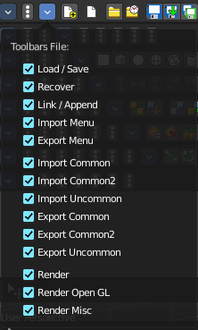
The Toolbars File contains some file menu related tools. Like load save. But also the render menu.

These toolbars are available in all modes.

Available Toolbars
The description of the single buttons goes from left to right.

Load / Save
The original menu items are in the File menu of the Info editor.

File New
Creates a new scene, using the current template.

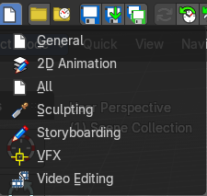
New from Template
Creates a new scene in one of the templates.

Open
Load a Blend file.

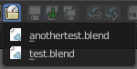
Open Recent
The recent files menu.

Save Blend File
Save a Blend file.

Save As Blend File
Save a Blend file as.

Save Copy
Saves a copy of the Blend file.

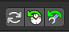
Recover

Revert
Reload the saved file.

Recover Last Session
Open the last closed file, which is stored in the quit.blend.

Recover Autosave
Open an automatically saved file to recover it. Like after a crash. See Preferences , Save & Load , Autosave

Link Append
The original menu items are in the File menu of the Info editor.

Link from Library
Link contend from a Blend file.

Append from Library
Append content.

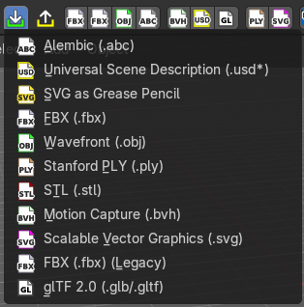
Import Menu
The Import menu is the same menu that you can find in the File menu of the Info editor. It contains all available file import types.
Note that im- and exporters are partially addons that can be disabled. So some content might miss.

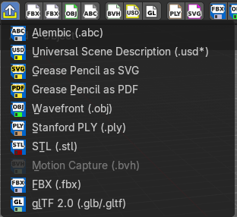
Export Menu
The Export menu is the same menu that you can find in the File menu of the Info editor.
It contains all available file export types.
Note that im- and exporters are partially addons that can be disabled. So some content might miss.


Import Common
The original menu items are in the File menu of the Info editor.

Import FBX
Import FBX files. Default version. wm.fbx_import.

Import FBX
Import FBX files. Legacy version. import_scene.fbx.

Import Obj
Import Object files.

Import ABC
Import Alembic files.

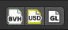
Import Common 2
The original menu items are in the File menu of the Info editor.

Import BVH
Import Biovision Motion Capture files.

Import USD
Import a USD file.

Import glTF2
Import glTF2 files.

Import Uncommon
The original menu items are in the File menu of the Info editor.

Import PLY
Import PLY files.

Import SVG
Import SVG Files.

Export Common
The original menu items are in the File menu of the Info editor.

Export FBX
Export as FBX file.

Export Obj
Export as Obj file.

Export ABC
Export as Alembic file.

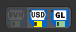
Export Common 2
The original menu items are in the File menu of the Info editor.

Export BVH
Export as BVH Motion Capture file.

Export USD
Export as USD file.

Export gITF2
Export as gITF2 file.


Export Uncommon
The original menu items are in the File menu of the Info editor.

Export PLY
Export as PLY file.

Render
The original menu items are in the Render menu of the Info editor.

Render Image
Renders the current scene as an image by using the current offline renderer. Either Blender Internal or Cycles.

Render Animation
Renders the current scene as an animation. Either Blender Internal or Cycles.

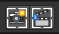
Viewport Render

Viewport Render Image
Renders the current scene as an image by using the Viewport and Open GL.

Viewport Render Animation
Renders the current scene as an animation by using the Viewport and Open GL.

Render Misc
The original menu items are in the Render menu of the Info editor.

Mixdown Audio
Mixdown and export the scene's audio to an audio file.

Show/ Hide Render view
Toggles display of Render view.

Play rendered animation
Play rendered Animation sequence.

Toolbars Mesh Edit

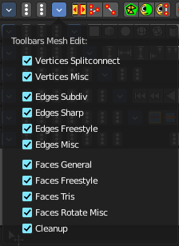
The Toolbars Mesh Edit contains tools for Mesh Objects in Edit Mode. The original menu items are mainly in the Mesh menu in Edit Mode. In the Vertices, Edges and Faces sub menus.

This toolbars shows its content Edit mode.

Available Toolbars
The description of the single buttons goes from left to right.

Vertices Split connect

Split
Splits two connected Vertices.

Vertex Connect Path
Connect Vertices by their selection order, creating edges, splitting faces

Vertex Connect
Connect selected vertices of faces, splitting the face.

Vertices Misc

Convex Hull
Enclose selected vertices in a convex polyhedron.

Blend from Shape
Blend in shape from a shape key.

Shape Propagate
Apply selected vertex locations to all other shape keys.

Edges Subdiv

Subdivide
Subdivides selected edges.

Subdivide Edge Ring
Subdivides an Edge Ring.

Un-Subdivide
Unsubdivides selected edges and faces.

Edges Sharp

Mark Sharp
Mark selected edges as sharp.

Unmark Sharp
Unmark selected edges as sharp.

Set Sharpness by Angle
Set edge sharpness based on the angle between neighbouring angles.

Edges Freestyle

Mark Freestyle Edge
Mark selected edges as Freestyle feature edges.

Unmark Freestyle Edge
Unmark selected edges as Freestyle feature edges.

Edges Rotate

Rotate
Rotate selected edges or adjoining faces.

Edges Misc

Edge Split
Split selected edges so that each neighbor face gets its own copy.

Bridge Edge loops
Create faces between selected edge loops.

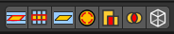
Faces general

Fill
Fill a selected edge loop with faces.

Grid Fill
Fill grid from two loops.

Beautify Faces
Rearrange some faces to minimize degeneration.

Solidify
Create a solid skin by extruding. Compensating for sharp angles.

Intersect
Cut an intersection into faces.

Boolean Intersect
Cut solid geometry from selected to unselected.

Wire Frame
Create a solid wire frame from faces.

Faces Freestyle

Mark Freestyle Face
Mark selected faces for exclusion from freestyle feature edge detection.

Unmark Freestyle Face
Unmark selected faces for exclusion from freestyle feature edge detection.

Faces Tris

Poke Faces
Split a face into a fan.

Triangulate Faces
Triangulates selected faces.

Tris to Quads
Join triangle faces into quads.

Split by Edges
Split faces by loose edges.

Faces Rotate Misc

Rotate UV's
Rotate UV coordinates inside faces.

Reverse UV's
Flip direction of UV coordinates inside faces.

Rotate Colors
Rotate Vertex Colors inside faces.

Reverse Colors
Flip direction of Vertex Colors inside faces.

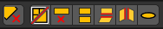
Cleanup

Delete Loose
Delete loose vertices, edges or faces.

Decimate Geometry
Simplify geometry by collapsing edges.

Degenerate Dissolve
Dissolve zero area faces and zero length edges.

Make Planar Faces
Flatten selected faces.

Split Non Planar Faces
Split non planar faces that exceeds the angle threshold.

Split Concave Faces
Make all faces convex.

Fill Holes
Fill in holes (boundary edge loops).

Toolbars Primitives

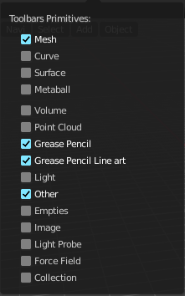
The toolbars Primitives contains the Add items from the Create tab.

The full toolbar with all its content is just available in Object mode. In other modes it hides away. Single types are also visible in Edit mode. When you work at a mesh type, then the Mesh primitives toolbar is visible for example.

Available Toolbars
The description of the single buttons goes from left to right.

Mesh
The Mesh toolbar contains the Mesh primitives.

Add Plane
Add a Plane primitive.

Add Cube
Add a Cube primitive.

Add Circle
Add a Circle primitive.

Add UV Sphere
Add a UV Sphere primitive.

Add Cylinder
Add a Cylinder primitive.

Add Cone
Add a Cone primitive.

Add Torus
Add a Torus primitive.

Add Grid
Add a Grid primitive.

Curve
The Curve toolbar contains the Curve primitives.

Add Bezier
Add a Bezier curve primitive.

Add Circle
Add a Circle curve primitive.

Add Nurbs Curve
Add a Nurbs Curve primitive.

Add Nurbs Circle
Add a Nurbs Circle curve primitive.

Add Nurbs Path
Add a Nurbs Path curve primitive.

Surface
The Surface toolbar contains the Surface primitives.

Add Surface Curve
Add a Nurbs Surface curve primitive.

Add Surface Circle
Add a Nurbs Surface Circle primitive.

Add Surface Patch
Add a Nurbs Surface Patch primitive.

Add Surface Cylinder
Add a Nurbs Surface Cylinder primitive.

Add Surface Sphere
Add a Nurbs Surface Sphere primitive.

Add Surface Torus
Add a Nurbs Surface Torus primitive.

Metaball
The metaball toolbar contains the Metaball primitives.

Add Metaball of type Ball
Add Metaball of type Ball primitive.

Add Metaball of type Capsule
Add Metaball of type Capsule primitive.

Add Metaball of type Plane
Add Metaball of type Plane primitive.

Add Metaball of type Ellipsoid
Add Metaball of type Ellipsoid primitive.

Add Metaball of type Cube
Add Metaball of type Cube primitive.

Point Cloud
The Point Cloud toolbar contains the Point Cloud primitive.

Add Point Cloud
Add a point cloud primitive.

Volume
The Volume toolbar contains the Volume primitives.

Import OpenVDB Volume
Imports a OpenVDP volume object.

Add Volume
Adds a volume object.

Grease Pencil

Blank
Inserts a blank Grease Pencil Object. A blank Grease Pencil Object has just one color

Stroke
Inserts a Stroke Grease Pencil Object. A Stroke Grease Pencil Object has a few standard colors already.

Monkey
Inserts a Monkey Grease Pencil Object. This is a grease pencil object which contains the shape of a monkey already. This monkey is an example object.

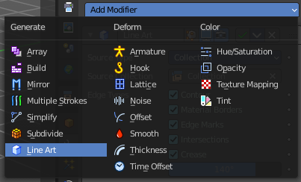
Scene Line Art
Line Art is a modifier for the grease pencil object. Scene Line Art adds a grease pencil object with the Line Art Modifer set up for the whole scene.

Collection Line Art
Line Art is a modifier for the grease pencil object. Scene Line Art adds a grease pencil object with the Line Art Modifer set up for a collection.

Lamp
The Lamp toolbar contains the different lamp types.

Add Lamp of type Point
Add Lamp of type Point.

Add Lamp of type Sun
Add Lamp of type Sun.

Add Lamp of type Spot
Add Lamp of type Spot.

Add Lamp of type Area
Add Lamp of type Area.

Other
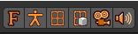
The Other toolbar contains some other ground types like bones and text.

Add Text
Add a Text object.

Add Armature
Add an Armature object.

Add Lattice Deformer
Add a Lattice deformer object.

Add Lattice
Add a Lattice object.

Add Camera
Add a Camera object.

Add Speaker
Add a Speaker object.

Empties
The Empties toolbar contains the available empty types.

Add Empty of type Plain Axes
Add Empty of type Plain Axes.

Add Empty of type Sphere
Add Empty of type Sphere.

Add Empty of type Circle
Add Empty of type Circle.

Add Empty of type Cone
Add Empty of type Cone.

Add Empty of type Cube
Add Empty of type Cube.

Add Empty of type Single Arrow
Add Empty of type Single Arrow.

Add Empty of type Arrows
Add Empty of type Arrows.

Add Empty of type Image
Add Empty of type Image.


Image

Images as Planes
Creates a mesh plane with an image.

Light Probe

Sphere
Adds a reflective light probe in sphere shape.

Plane
Adds a reflective light probe in plane shape.

Volume
Adds a volumetric array light probe.

Force Field
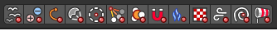
The Force Field toolbar contains the available Force field types.

Add Physics Effector of Type Boid
Add Physics Effector of Type Boid.

Add Physics Effector of Type Charge
Add Physics Effector of Type Charge.

Add Physics Effector of Type Curve Guide
Add Physics Effector of Type Curve Guide.

Add Physics Effector of Type Drag
Add Physics Effector of Type Drag.

Add Physics Effector of Type Force
Add Physics Effector of Type Force.

Add Physics Effector of Type Harmonic
Add Physics Effector of Type Harmonic.

Add Physics Effector of Type Lenard-Jones
Add Physics Effector of Type Lenard-Jones.

Add Physics Effector of Type Magnetic
Add Physics Effector of Type Magnetic.

Add Physics Effector of Type Fluid Flow
Add Physics Effector of Type Fluid Flow.

Add Physics Effector of Type Texture
Add Physics Effector of Type Texture.

Add Physics Effector of Type Turbulence
Add Physics Effector of Type Turbulence.

Add Physics Effector of Type Vortex
Add Physics Effector of Type Vortex.

Add Physics Effector of Type Wind
Add Physics Effector of Type Wind.

Collection

Add Collection Instance
Add a collection instance.

Toolbars Image

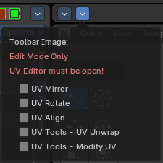
The toolbars Image contains some image related tools. At the moment this toolbar contains just tools to edit UV meshes. This means that you have to be in Edit mode with an UV mapped mesh to make the tools active.
The original menu items are in the Image menu of the UV Image Editor.
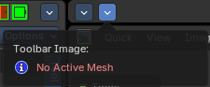
Note that the tools does not show when you are not in edit mode. And the tools just works for the UV Editor. And of course you need a mesh object.

Available Toolbars
The description of the single buttons goes from left to right.

UV Mirror
Mirror along X or Y axis.

UV Rotate
Rotate by 90 degrees clockwise or counter clockwise.

UV Align
The UV Align toolbar contains tools to clean up and align the selected UV geometry.

Align Straighten
Align UV's along the line defined by the end points of the selection.

Align Straighten X
Align UV's along the line defined by the end points along the X axis.

Align Straighten Y
Align UV's along the line defined by the end points along the Y axis.

Align Auto
Automatically choose the axis on which there is most alignment already.

Align X
Align UV's at X axis.

Align Y
Align UV's at Y axis.

Align Rotation
Aligns the rotation of the selected geometry.

UV Unwrap
The UV Common toolbar contains tools for unwrapping.

Mark Seam
Mark selected UV Edges as Seam.

Clear Seam
Remove Seam from selected UV Edges.

Seams from Islands
Marks the border edges of the UV patches as Seam.

Unwrap Angle Based
Unwraps the selected geometry with the Angle based ( ABF ) method.

Unwrap Conformal
Unwraps the selected geometry with the Conformal ( LSCM ) method.

Unwrap Minimize Stretch
Unwraps the selected geometry with the SLIM method.

Cube Projection
Maps the selected geometry with a cube projection.

Cylinder Projection
Maps the selected geometry with a cylinder projection.

Sphere Projection
Maps the selected geometry with a sphere projection.

UV Modify UV
The UV Modify toolbar contains tools to clean up the UV mapping.

Pin
Pins the selected vertices.

Unpin
Unpins the selected vertices.

Weld
Weld the selected UV vertices together.

Remove Doubles UV
Removes double vertices

Average Island Scale
Average the size of separated UV patches, based at their size in 3D space.

Pack Island
Packs the UV patches so that they fit best into the UV space, and as few texture space as possible is wasted.

Copy mirrored UV Coordinates
Copy mirrored UV Coordinates at X axis based on a mirrored mesh.

Toolbars Tools

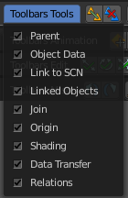
The Toolbars Tools contains some tools in object mode. The content from the relations panel and the edit panel in the tool shelf. And one tool in Edit mode. Make Vertex Parent. Since this is also part of the relations panel.

Available Toolbars
The description of the single buttons goes from left to right.

Parent

Make Parent
Parents the selected object to the active object.

Clear Parent
Removes the parenting.

Object to Data

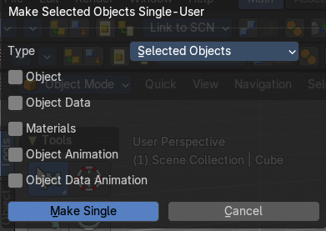
Make Single User
Make linked data local to each object. This operator opens a popup to adjust further settings.

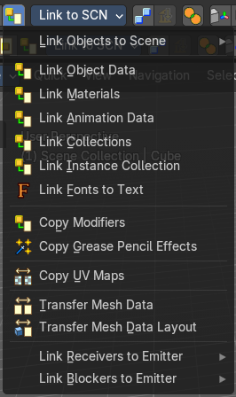
Link Data
Apply active object links to other selected objects.
This button is a menu to choose the link method.

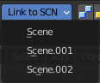
Link to SCN

Link to SCN
Link selection to another scene. This other scene has of course to exist.

Linked Objects

Make Local
Make library linked data blocks local to this file.

Make Library Override
Add empty object to become local replacement data of a library linked object.

Join

Join
Join selected objects into active objects.

Origin

Set Geometry to Origin
Sets the geometry to origin.

Set Origin to Geometry
Sets the origin to geometry.

Set Origin to 3D cursor
Sets the origin to the 3D cursor.

Set Origin to Center of Mass
Sets the origin to the center of mass.

Set Origin to Center of Volume
Sets the origin to the center of volume.

Shading

Shade Smooth
Shades the geometry smooth.

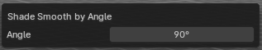
Shade Smooth by Angle
Activate auto smooth, and define the angle. Note that you need to call the adjust last operator here to set the angle. Either with the Last button. Or with the hotkey F6.

Shade Flat
Shades the geometry flat.

Data Transfer

Transfer Mesh Data
Transfers mesh data.

Transfer Mesh Data Layout
Transfers the mesh data layout.

Join UV's
Transfer UV Maps.

Relations
The Relations toolbar contains one tool in Edit mode. Make Vertex Parent.

Make Vertex Parent
Parents an object to the selected vertice(s).

Toolbars Animation

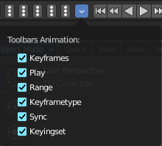
The Toolbars Animation contains tools around animation. The Toolbars Range, Play, Sync and Keying set are the toolbars from the Timeline. But separated into four independent parts.

Available Toolbars
The description of the single buttons goes from left to right.

Keyframes
The Keyframes toolbar contains some keyframe tools. The original menu items can be found in the Tool Shelf in the Animation tab in the Animation panel.
The original menu items are in the Tool Shelf in the 3D View, in the Animation tab in the Animation panel.

Insert Keyframe Menu
When there is no keying set assigned to the currently selected object, then this button is a menu to choose a keying set. When there is already a keying set assigned, then you can record a keyframe with this button

Delete Keyframe
Deletes the current Keyframe

Bake Action
Bakes the animation to a new action

Remove Animation
Remove all keyframe animation for selected objects

Calculate Object Paths
Calculate motion paths for the selected objects.

Clear Object Paths
Clears motion paths for the selected objects.

Play

Jump to Endpoint
Jumps to beginning of animation.

Jump to Keyframe
Jumps to the previous keyframe Play Animation.

Play Animation
Plays animation reversed.

Play Animation
Plays animation forward.

Jump to Keyframe
Jumps to next keyframe.

Jump to Endpoint
Jumps to end of animation.

Current Frame
The current frame number.

Range

Use Preview Range
Use an alternative start/end frame grange for animation playback and OpenGL renders instead of the Render Properties start/end frame range.

Lock Frame Selection to Range
Don't allow frame to be selected with mouse outside of frame range.

Frame Start
The frame start point.

Frame End
The frame end point.

Keying set

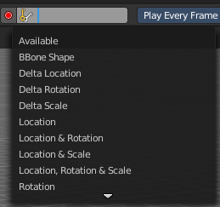
Insert Keyframe
Insert a keyframe.

Delete Keying set Keyframe
Delete Keyframe.

Use Keyframe Insert Auto
Auto insert keyframes at manipulation.

Keying set Drop down box
This is a drop down box to choose the keying set method.

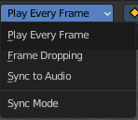
Sync
Sync is a drop down box where you can adjust the syncing method.

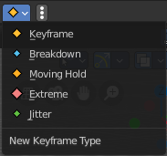
Keyframe Type
Keyframe Type is a drop down box to choose in what color the keyframe gets displayed in the Dope Sheet Editor.

Toolbars Edit

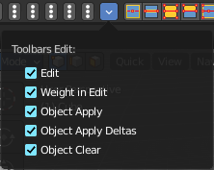
The Toolbars Edit contains various toolbars around editing. Some content just shows when an object exists in the scene. Some content is visible in Object mode. Some content is visible in Edit mode.

Available Toolbars
The description of the single buttons goes from left to right.

Edit
The Edit toolbar is just visible in Edit Mode. The original menu items are in the Tool Shelf in the 3D View in the Tools tab in the Mesh Tools panel.

Dissolve Vertices
Dissolve Vertices.

Dissolve Edges
Dissolve Edges.

Dissolve Faces
Dissolve Faces.

Remove Doubles
Removes double vertices.

Limited Dissolve
Dissolve Edges and Vertices limited by the surrounding angle.

Dissolve Selection
Dissolve Geometry dependent of selection mode.

Edge Collapse
Collapse selected edges.

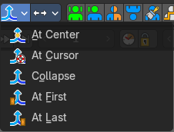
Merge
Merges selected geometry. This is a drop down box to choose where to merge.

Separate
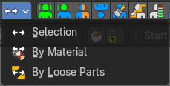
Separate the selection, and create a new object from it. This is a drop down box to choose the separate method.

Weight in Edit
The Weight in Edit toolbar is just visible in Edit Mode for normal meshes, and Pose mode when you have a rigged character selected. The original menu items are in the Tool Shelf in the 3D View in the Tools tab in the Weight Tools panel. You need to have a Vertex Group applied.

Normalize all
Normalizes the whole mesh.

Normalize
Normalizes the selection

Mirror
Mirrors the selection.

Invert
Inverts the weighting.

Clean
Remove Vertex Assignments that are not required.

Quantize
Set Weights to a fixed number of steps.

Levels
Add some offset and multiply with some gain the weights of the active vertex group.

Smooth
Smooth weights for selected vertices.

Limit Total
Limit deform weights.

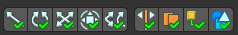
Object Apply
The Object Apply toolbar is just visible in Object Mode. The original menu items are in the Object menu in the 3D View. The Apply menu.

Apply Location
Apply location.

Apply Rotation
Apply Rotation.

Apply Scale
Apply Scale.

Apply All
Apply Location, Rotation, Scale.

Apply Rotation & Scale
Apply Rotation, Scale.

Apply Visual Transform
Apply Visual Transform.

Make Instances real
Make Duplicates attached to this object real.

Apply Parent Inverse
Apply the object’s parent inverse to its data

Visual Geometry to Objects
Convert geometry and instances into editable objects and collections.

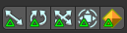
Object Apply Deltas
Object Apply deltas converts normal object transforms to delta transforms. Any existing delta transform will also be included.

Location
Apply location.

Rotation
Apply Rotation.

Scale
Apply Scale.

All
Apply Location, Rotation, Scale.

Transforms to Delta Anims
Convert object animation for normal transforms to delta transforms.

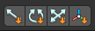
Object Clear
The Object Clear toolbar is just visible in Object Mode. The original menu items are in the Object menu in the 3D View. The Clear menu.

Location
Resets the position of the object to zero.

Rotation
Resets the object's rotation to zero.

Scale
Resets the object's scale to 1.

Origin
Resets the Origin Position.

Toolbars Misc

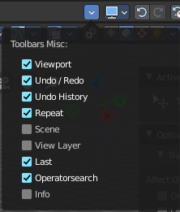
The Toolbars Misc contains some miscellaneous tools. Undo, the Scene drop down box, Last Operator, Operator Search and scene informations.

Available Toolbars
The description of the single buttons goes from left to right.

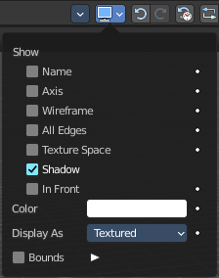
Viewport
Displays the viewport panel from the object properties tab in the properties editor.
This panel allows you to adjust the display of the selected object.
Note that you need to have an object selected to show this dropdown panel.

Undo / Redo

Undo
Undo the last step

Redo
Redo the last undone step

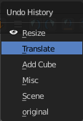
Undo History

Undo History
A click at at the button reveals a list of the last operations where you can undo more than one step.

Repeat

Repeat
Repeats the last action

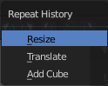
Repeat History
A click at at the button reveals a list of the last operations to choose from which undo step to repeat.

Scene
The Scene drop down box to choose and create a new scene data block. The original drop down box is in the Properties editor in the Scene Properties tab in the Scene panel.

View Layer
Show the active view layer and switch between available view layers.
The original drop down box is in the Properties editor in the View Layer Properties in the View Layer panel.

Adjust last Operation
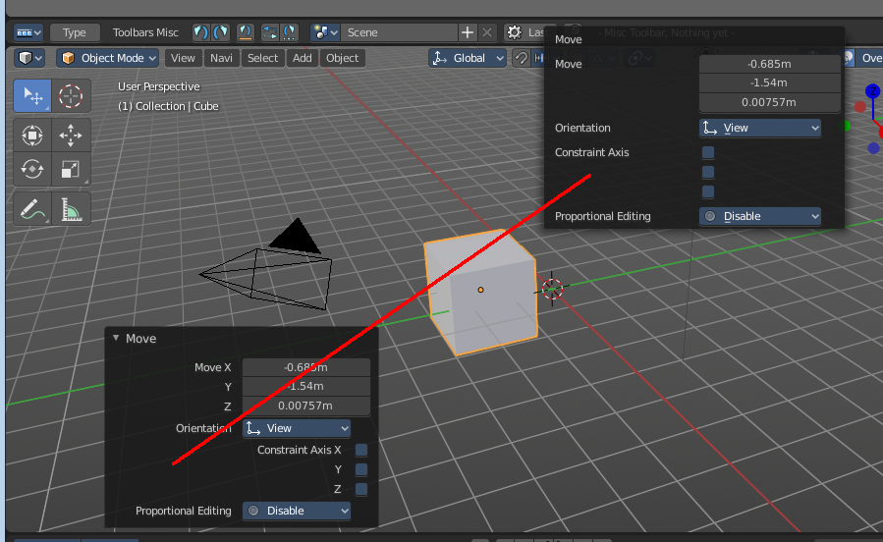
Adjust the latest operation. This is the same panel than the one in the 3D view down left. At least when it comes to content.

Operatorsearch
This toolbar contains two search options. The search menu allows you to search for menus. The operator search menu allows you to search for single operators.

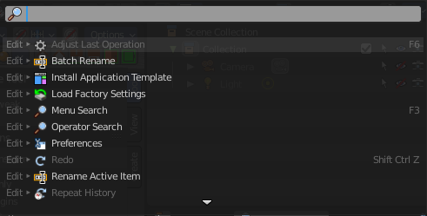
Search Menu
The original menu item is in the header in the Edit menu. It lists the available menus, and allows searching.
This button calls the menu search menu.

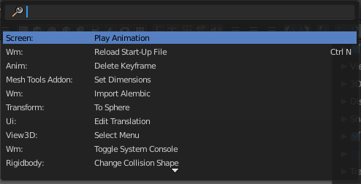
Search Operator
The original menu item is in the header in the Edit menu.
This button calls the Operator search menu. It lists the available operators, and allows searching.

Info
The Info toolbar displays the scene statistics.

